Gaming-Bets

Software Architecture Document

Version 1.0

Revision History
Date | Version | Description | Author
15.11.15 | 01.00.00 | document created | Niclas Petersohn

Table of Contents
1. Introduction 2
1.1 Purpose 2
1.2 Scope 2
1.3 Definitions, Acronyms, and Abbreviations 2
1.4 References 2
1.5 Overview 2
2. Architectural Representation 2
3. Architectural Goals and Constraints 2
4. Use-Case View 2
4.1 Use-Case Realizations 2
5. Logical View 2
5.1 Overview 2
5.2 Architecturally Significant Design Packages 2
6. Process View 2
7. Deployment View 2
8. Implementation View 2
8.1 Overview 2
8.2 Layers 2
9. Data View (optional) 2
10. Size and Performance 2
11. Quality 2

Software Architecture Document

Introduction

Purpose
This document provides a comprehensive architectural overview of the system, using a number of different architectural views to depict different aspects of the system. It is intended to capture and convey the significant architectural decisions which have been made on the system.

Scope
tbd

Definitions, Acronyms, and Abbreviations
MVC – Model View Controller

References

Overview
tbd
[This subsection describes what the rest of the Software Architecture Document contains and explains how the Software Architecture Document is organized.]

Architectural Representation
This Project will use MVC Principles for development. However, since pure MVC is not quite possible within Android we won't be using a popular framework.
[This section describes what software architecture is for the current system, and how it is represented. Of the Use-Case, Logical, Process, Deployment, and Implementation Views, it enumerates the views that are necessary, and for each view, explains what types of model elements it contains.]

Architectural Goals and Constraints
Since our App will mainly have to deal with data management (e.g. user data, game data) using an MVC structure in combination with a client-server technology will be the approach. The goal is to let the server (controller) handle all the man tasks on our database (model) so the App Client itself (View) will mainly be responsible for providing a UI for our users.

Use-Case View
tbd

Use-Case Realizations
tbd

Logical View
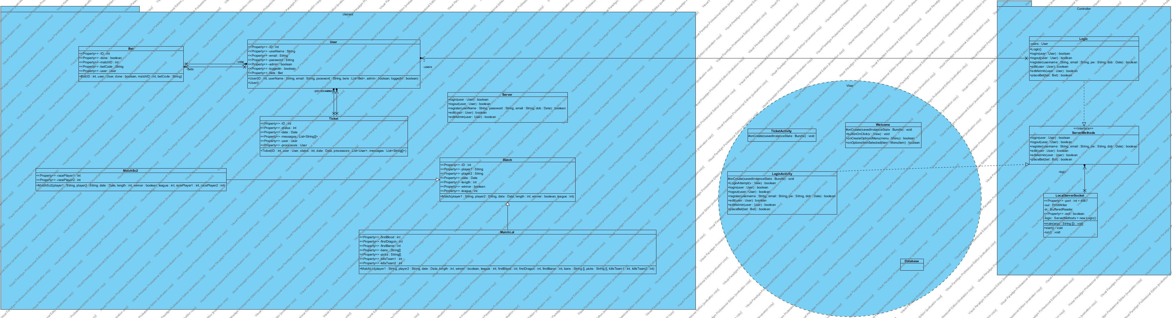

Process View
tbd

Deployment View

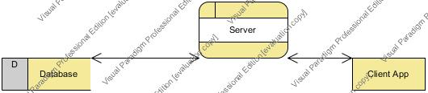

Implementation View
tbd

Data View (optional)
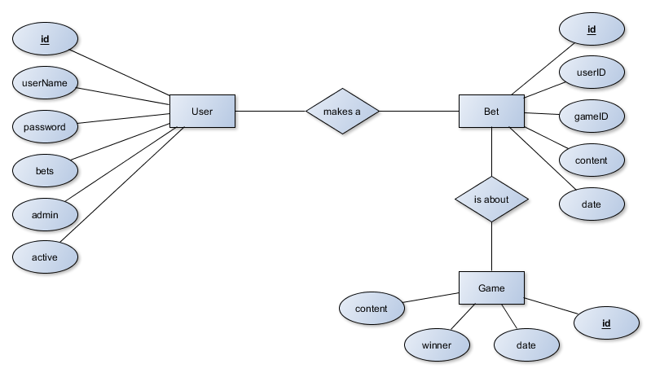

Size and Performance
tbd

Quality
tbd

